**Admin-middleware**

1.**Http\Kernel.php**

protected **$routeMiddleware** = [

...

**'admin' => \App\Http\Middleware\Admin::class,**

];

2.**Http\Middleware\Admin.php** - just copy from **laravel-cards**

**if ($user && $user->role === 'admin')** {…

3.**routes\web.php**

Route::prefix('')->namespace('Back')->group(function () {

Route::**middleware('admin')**->group(function () {

Route::name('dashboard')->get('/dashboard', 'AdminController@index');

});

});

**/dashboard** для **admin**

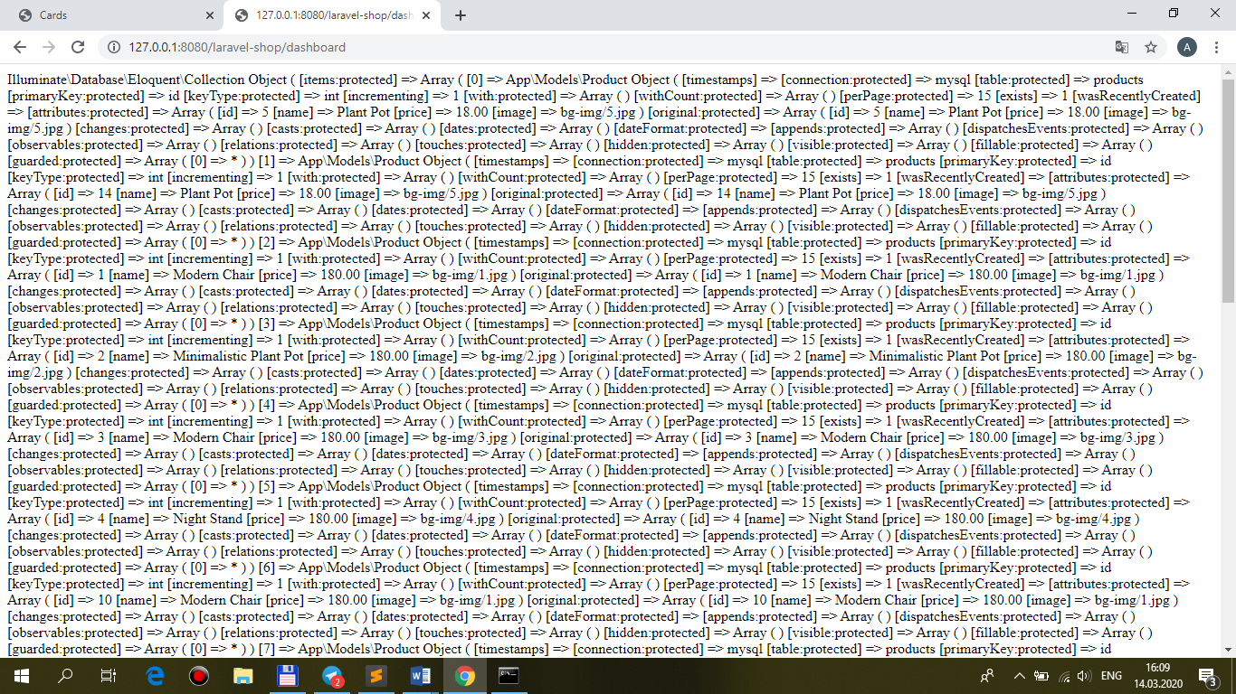

**/dashboard** for **serg**

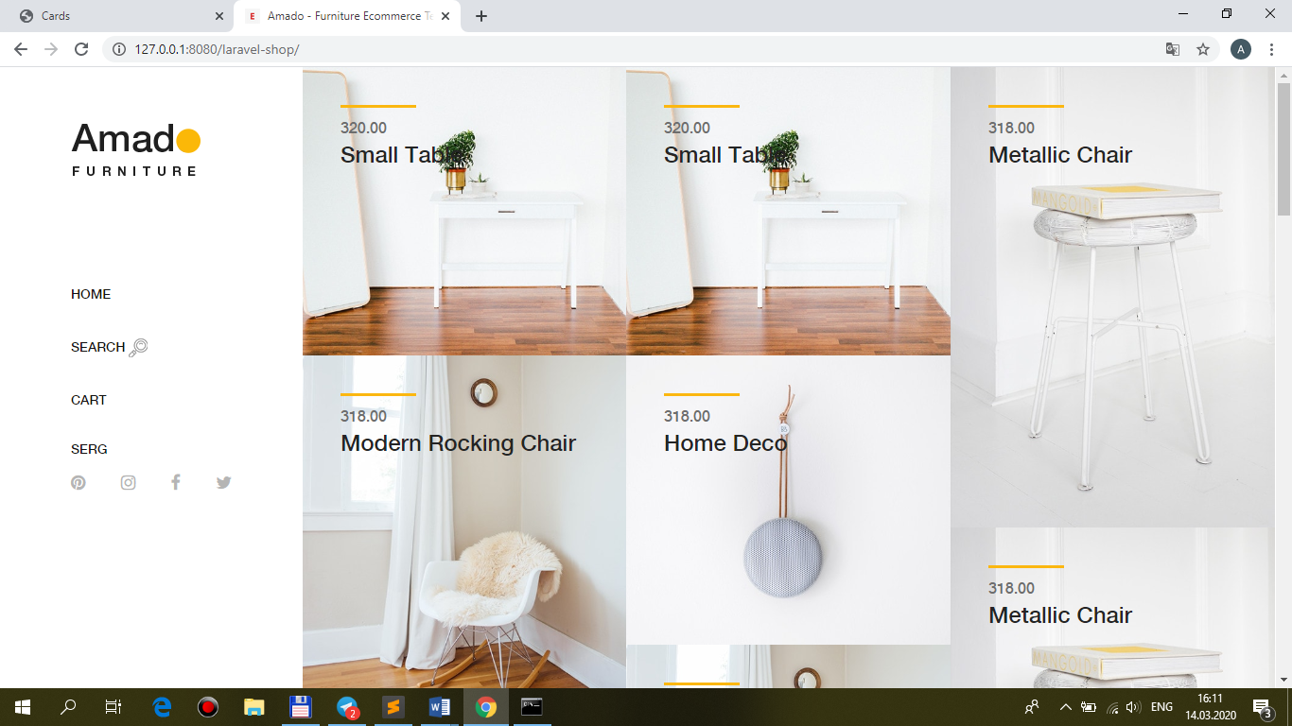

**view-AdminLTE**

**AdminLTE** – по **аналогии с занятием** сделать из исходников (**index.html + add.txt**)

+свои заголовки – **PRODUCTS,** List of **Products,** Add new **Product,** '**product**-updated',

<td>**Image**</td>

<td>**Name**</td>

<td>**Price**</td>

<td>**Top9**</td>

…

+ **public\AdminLTE**

+php artisan view:clear

